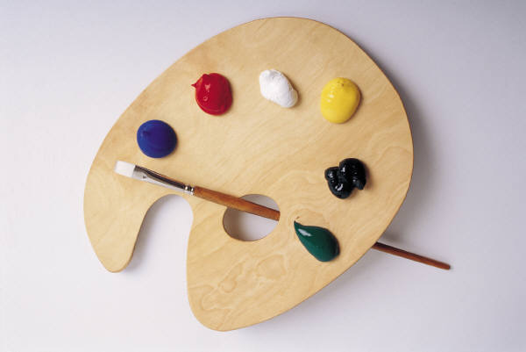
St. Paul’s First Lutheran Parent Teacher Fellowship Presents:
AFTER-SCHOOL ART WORKSHOP
September 20 – October 25, 2017
The new school year is here and so are the colors of Fall that come with it! Bring out your inner impressionist and paint your masterpiece! This workshop is an introduction to art/crafts, watercolor, oil pastels, mixed-media, collage and instructed by professional artist/teacher and St. Paul’s parent Shogher Tilkian. Classes will be 3:30 – 4:30 pm.
1st – 4th GRADES……………………………….………..WEDNESDAY 3:30 – 4:30 PM
5TH – 8TH GRADES………………………………………..THURSDAYS 3:30 – 4:30 PM
6 CLASSES……………………………………………………….....$70.00/student
The $70.00 inlcudes a $10 materials fee per student. Make checks payable to St. Paul’s First Lutheran School.

…………………………………………………..APPLICATION…….………………………………………………
STUDENT’S NAME: ______________________________________________________ AGE_________
PARENT’S NAME: ____________________________________________________________________
ADDRESS: __________________________________________________________________________
HOME TEL: ________________________________ WORK TEL: _______________________________
PARENT’S SIGNATURE: __________________________________________ DATE: ______________
FEE: CASH CHECK

